Thank you for taking the time to appear on the Profits Through Podcasting Podcast!

Profits Through Podcasting speaks to thousands of listeners around the world who are eager to learn how to generate leads and revenue for their business by using their podcast as a marketing tool.

You can find more about the podcast at www.profitsthroughpodcasting.com. You should have also received an e-mail containing the link to join our session on recording day, along with some details about which topics and questions we’ll be covering.
We expect the interview to run anywhere from about 30 minutes, but have allotted up to 60 minutes for the session to include some time to chat before we get started.

Here are the subjects we were hoping to get into, and of course anything else of interest that comes up.

- Why did you decide to start podcasting? What were your goals?
- What is your business and what do you sell?
- In what ways have you seen podcasting help generate leads and revenue for your business?

Below we’ve included some technical details and additional pointers to help us record a great interview. Please review and get in touch if you have any questions leading up to our interview date.

This will be a recorded audio+video interview conducted through Zoom, which you have likely used in the past. The video will/will not be published online.

To participate, you will need a desktop computer or mobile/tablet device with the Zoom application installed. You can find it on their website https://zoom.us/. A wired internet connection is strongly preferred rather than WiFi.

You will receive an e-mail containing a link to connect the meeting, which you will open at the scheduled time.

While a high-quality microphone is not necessary for the interview (though if you have one, please use it!) the use of headphones is imperative.

The quality of the headphones is not important, just the fact that you use them. This prevents a number of audio issues and makes for a much better-sounding finished product.

In addition to using headphones, it is helpful to record in the most ideal environment possible. This would include an area with low-echo and free of interruptions or external noises such as traffic, other people, etc.

We’ll be recording video footage as well, so please choose a recording location that you’re comfortable being seen by others or use Zoom’s background replacement feature!

Please follow these steps to check for the optimal Zoom settings:
- Open Zoom’s Settings, then select Audio on the left.
- Under Audio Profile, select Original sound for musicians then tick boxes as shown in the image below.

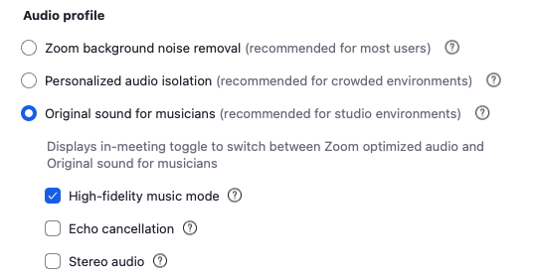

- When we begin the meeting, the following setting will appear at the top left of the meeting window. Click to turn Original Sound ON, but only if you are wearing headphones.



Once connected we will do a brief soundcheck to ensure everything is good.

Recording Checklist:

- Please silence all phone and/or computer notification sounds.
- Use a wired internet connection when possible. If using WiFi, ensure a strong, stable signal is present.
- Pause or close and bandwidth-intensive applications, such as Dropbox.
- Have something to drink nearby, preferably water.
- Limit any noises such as squeaky chairs, clicking a pen, jewelry, tapping the desk, etc.
- Minimize the use of crutch words and phrases such as “like”, “um”, “you know”, etc.
- Let others around you know that you’ll be recording and should not be disturbed.

Remember to relax and have fun! Mistakes and long hesitations can always be edited out.

Having trouble? Check Zoom’s official support page.

You can also e-mail or call me if you are not able to connect.

